User Acceptance Testing (UAT) Template
Date | 30 September 2026
Team ID | SWTID-2026-8886
Project Name | Implement Client Script and UI Policy for Incident
Maximum Marks

Project Overview:
Project Name: Implement Client Script and UI Policy for Incident
Project Description: Incident client-side controls for high-impact routing and State list workflow.
Project Version: 0.1
Testing Period: To be scheduled; not run
Testing Scope:
High Impact UI Policy, Urgency onChange, high-impact onSubmit validation, policy reversal, State list edit, form State update.
USN-1 through USN-8; FR-1 through FR-6.
Testing Environment:
URL/Location: ServiceNow non-production instance to be supplied by team.
Credentials (if required): Use assigned test account; do not record credentials in this report.
Test Cases:
Test Case ID | Test Scenario | Test Steps | Expected Result | Actual Result | Pass/Fail
TC-001 | High impact on load | Open Incident with Impact=1 | Group and assignee mandatory; Urgency read-only | Not run | Not run
TC-002 | Urgency auto-set | Change Impact to 1 | Urgency becomes 1 | Not run | Not run
TC-003 | Missing group | Submit Impact=1 without group | Save blocked with group message | Not run | Not run
TC-004 | Missing assignee | Submit Impact=1 without assignee | Save blocked with assignee message | Not run | Not run
TC-005 | Successful high impact | Fill both routing fields and submit | Saves subject to other rules | Not run | Not run
TC-006 | Reverse policy | Change Impact from 1 to 2 | Policy effects reverse; values remain | Not run | Not run
TC-007 | List State edit | Edit State from list | Change declined with guidance | Not run | Not run
TC-008 | Form State update | Change State on form | Platform rules decide save | Not run | Not run

Bug Tracking:
Bug ID | Bug Description | Steps to reproduce | Severity | Status | Additional feedback
No defect record | UAT has not run; defects are not assessed. | Not applicable | Not assessed | Not run | Update this row if a defect is found.

Sign-off:
Tester Name: To be assigned
Date: Pending execution
Signature: Pending
Notes:
- Ensure that all test cases cover both positive and negative scenarios.
- Encourage testers to provide detailed feedback, including any suggestions for improvement.
- Bug tracking should include details such as severity, status, and steps to reproduce.
- Obtain sign-off from both the project manager and product owner before proceeding with deployment.

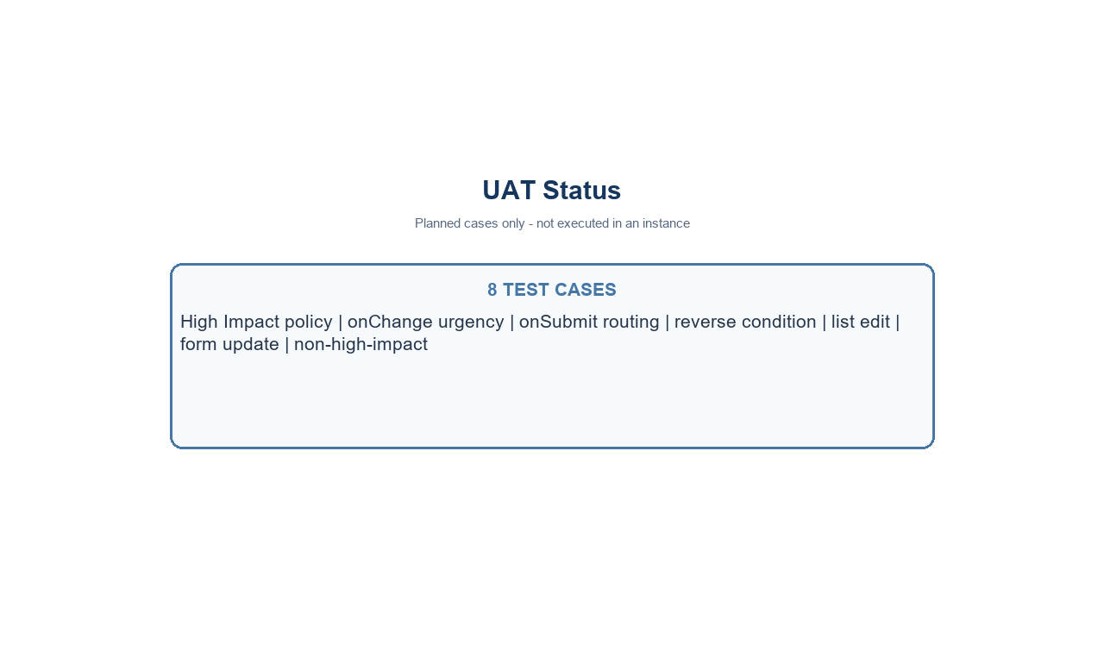
Conceptual Incident form - not a live instance screenshot
Project note: values use the standard Incident choices where Impact 1 and Urgency 1 represent High. Confirm field names and values in the target instance.

